Using a list
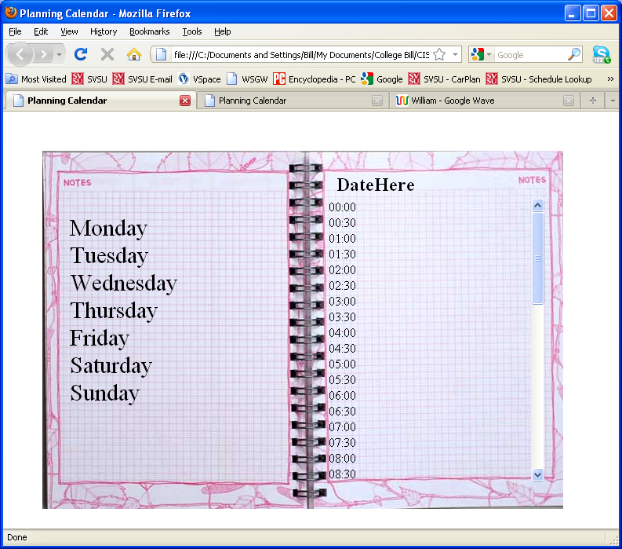

HTML
"http://www.w3.org/TR/xhtml1/DTD/xhtml1-transitional.dtd">
<html xmlns="http://www.w3.org/1999/xhtml">

<head>

<title>Planning Calendar</title>

<link rel="stylesheet" type="text/css" href="CSS/main_Old.css" />
<meta http-equiv="content-type"
content="text/html; charset=iso-8859-1" />

</head>
<body>

<h2 id="heading2">DateHere</h2>

<div id="datebook"><img src="images\datebook1.jpg" alt="Date Book" /></div>

<ul id="time">
<li>00:00</li>
<li>00:30</li>
<li>01:00</li>
<li>01:30</li>
<li>02:00</li>
<li>02:30</li>
<li>03:00</li>
<li>03:30</li>
<li>04:00</li>
<li>04:30</li>
<li>05:00</li>
<li>05:30</li>
<li>06:00</li>
<li>06:30</li>
<li>07:00</li>
<li>07:30</li>
<li>08:00</li>
<li>08:30</li>
<li>09:00</li>
<li>09:30</li>
<li>10:00</li>
<li>10:30</li>
<li>11:00</li>
<li>11:30</li>
<li>12:00</li>
<li>12:30</li>
<li>13:00</li>
<li>13:30</li>
<li>14:00</li>
<li>14:30</li>
<li>15:00</li>
<li>15:30</li>
<li>16:00</li>
<li>16:30</li>
<li>17:00</li>
<li>17:30</li>
<li>18:00</li>
<li>18:30</li>
<li>19:00</li>
<li>19:30</li>
<li>20:00</li>
<li>20:30</li>
<li>21:00</li>
<li>21:30</li>
<li>22:00</li>
<li>22:30</li>
<li>23:00</li>
<li>23:30</li>
</ul>

<ul id="day">
<li id="mon">Monday</li>
<li id="tues">Tuesday</li>
<li id="wed">Wednesday</li>
<li id="thur">Thursday</li>
<li id="fri">Friday</li>
<li id="sat">Saturday</li>
<li id="sun">Sunday</li>
</ul>
</body>
</html>

CSS
#time{width:275px;height:360px;overflow:auto;}

li{list-style-type:none;}

#time{position:absolute;top:95px;left:375px;z-index:1;}

#heading2{position:absolute;top:60px;left:425px;z-index:1;}

#datebook{position:absolute;top:50px;left:50px;}

#day{position:absolute;font-size:30px;top:100px;left:45px;z-index:1;}

USING A SELECTION
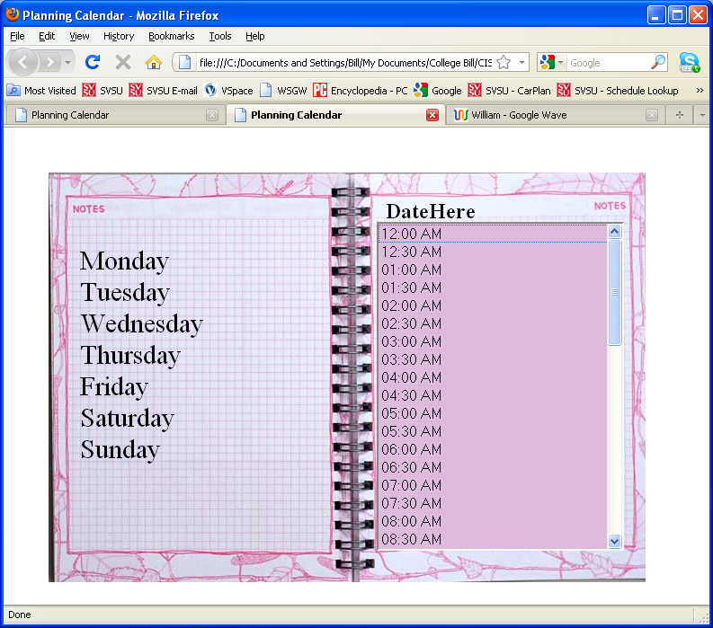

HTML
<!DOCTYPE html PUBLIC "-//W3C//DTD XHTML 1.0 Transitional//EN"
"http://www.w3.org/TR/xhtml1/DTD/xhtml1-transitional.dtd">
<html xmlns="http://www.w3.org/1999/xhtml">

<head>

<title>Planning Calendar</title>

<link rel="stylesheet" type="text/css" href="CSS/main.css" />
<meta http-equiv="content-type"
content="text/html; charset=iso-8859-1" />

</head>
<body>

<h2 id="heading2">DateHere</h2>

<div id="datebook"><img src="images\datebook1.jpg" alt="Date Book" /></div>

<select id="time" size="18">
<option value="0000">12:00 AM</option>
<option value="0030">12:30 AM</option>
<option value="1000">01:00 AM</option>
<option value="1030">01:30 AM</option>
<option value="0200">02:00 AM</option>
<option value="0230">02:30 AM</option>
<option value="0300">03:00 AM</option>
<option value="0330">03:30 AM</option>
<option value="0400">04:00 AM</option>
<option value="0430">04:30 AM</option>
<option value="0500">05:00 AM</option>
<option value="0530">05:30 AM</option>
<option value="0600">06:00 AM</option>
<option value="0630">06:30 AM</option>
<option value="0700">07:00 AM</option>
<option value="0730">07:30 AM</option>
<option value="0800">08:00 AM</option>
<option value="9730">08:30 AM</option>
<option value="0900">09:00 AM</option>
<option value="0930">09:30 AM</option>
<option value="1000">10:00 AM</option>
<option value="1030">10:30 AM</option>
<option value="1100">11:00 AM</option>
<option value="1130">11:30 AM</option>
<option value="1200">12:00 PM</option>
<option value="1230">12:30 PM</option>
<option value="1300">01:00 MP</option>
<option value="1330">01:30 PM</option>
<option value="1400">02:00 PM</option>
<option value="1430">02:30 PM</option>
<option value="1500">03:00 PM</option>
<option value="1530">03:30 PM</option>
<option value="1600">04:00 PM</option>
<option value="1630">04:30 PM</option>
<option value="1700">05:00 PM</option>
<option value="1730">05:30 PM</option>
<option value="1800">06:00 PM</option>
<option value="1830">06:30 PM</option>
<option value="1900">07:00 PM</option>
<option value="1930">07:30 PM</option>
<option value="2000">08:00 PM</option>
<option value="2930">08:30 PM</option>
<option value="2100">09:00 PM</option>
<option value="2130">09:30 PM</option>
<option value="2200">10:00 PM</option>
<option value="2230">10:30 PM</option>
<option value="2300">11:00 PM</option>
<option value="2330">11:30 PM</option>
</select>

<ul id="day">
<li id="mon">Monday</li>
<li id="tues">Tuesday</li>
<li id="wed">Wednesday</li>
<li id="thur">Thursday</li>
<li id="fri">Friday</li>
<li id="sat">Saturday</li>
<li id="sun">Sunday</li>
</ul>
</body>
</html>

CSS
select, option {font-size:16px;width:275px;overflow:hidden;}

select{position:absolute;top:105px;left:415px;z-index:1;background-color:#DDBBDD;}

#heading2{position:absolute;top:60px;left:425px;z-index:1;}

#datebook{position:absolute;top:50px;left:50px;}

#day{position:absolute;font-size:30px;top:100px;left:45px;z-index:1;}

li{list-style-type:none;}

